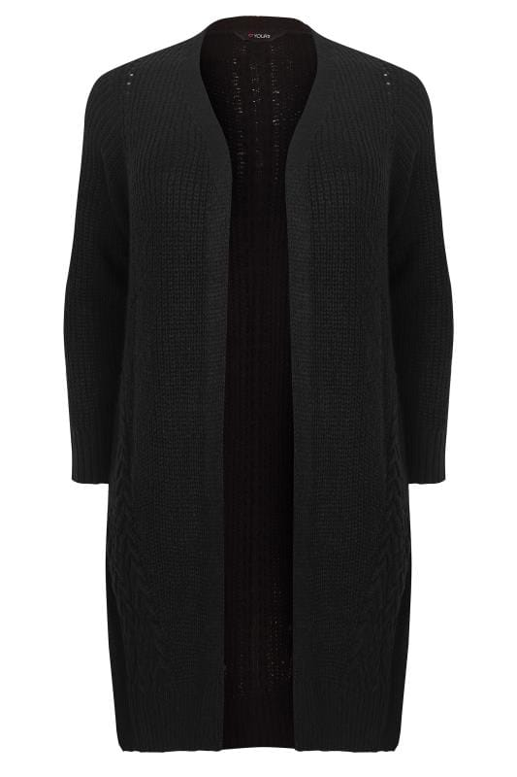

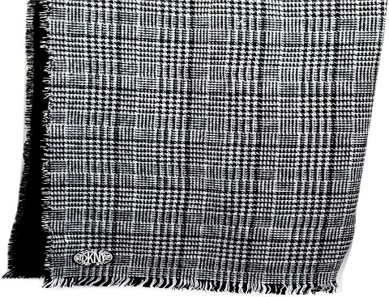

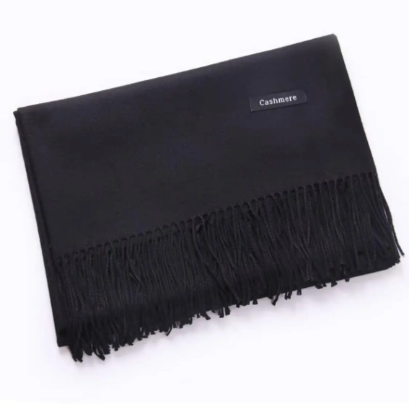

**Knitted cardigans are not acceptable as part of the Holly Lodge uniform policy so therefore should not be worn.**

**Dark coloured shoulder scarfs (Black, Navy Blue, Charcoal Grey) are acceptable but should NOT be worn in school.**